Frontend and AI

GIthub Link: https://github.com/Divyasri6/Bug-Tracking

Frontend:
The Bug Tracker Frontend is a modern React application built with Vite, React Router, and Tailwind CSS. It provides a user-friendly interface for managing bugs, viewing dashboards, and getting AI-powered suggestions.

Tech Stack:
- React 18+
- Vite (Build Tool)
- React Router DOM (Navigation)
- Tailwind CSS (Styling)
- Axios (HTTP Client)
- React Hot Toast (Notifications)
- Lucide React (Icons)

Installation:
npm create vite@latest bug-tracker-frontend --template react
cd bug-tracker-frontend
npm install
npm install axios react-router-dom react-hot-toast
npm install -D tailwindcss postcss autoprefixer
npx tailwindcss init -p

Folder Structure
## Project Structure

```
bug-tracker-frontend/
├── public/
│ └── vite.svg
├── src/
│ ├── assets/
│ ├── components/
│ │ ├── Navbar.jsx # Top navigation bar
│ │ └── StatusBadge.jsx # Status and Priority badge components
│ ├── pages/
│ │ ├── Home.jsx # Dashboard with summary stats
│ │ ├── BugList.jsx # List of all bugs (table/card view)
│ │ ├── CreateBug.jsx # Create new bug form
│ │ ├── EditBug.jsx # Edit existing bug form
│ │ └── ViewBug.jsx # View bug details
│ ├── services/
│ │ ├── api.js # Axios instance configuration
│ │ ├── bugService.js # Bug-related API calls
│ │ └── aiService.js # AI service API calls
│ ├── App.jsx # Main app component with routing
│ ├── main.jsx # Application entry point
│ └── index.css # Global styles and Tailwind imports
├── index.html
├── package.json
├── vite.config.js
└── tailwind.config.js
```

AI Services:
The AI Service is a Python FastAPI application that provides AI-powered bug analysis and suggestions using OpenAI's GPT models. It analyzes bug reports and provides intelligent suggestions for fixing issues.
Steps:
- Created virtual environment
- cd api-serice
pip3 install -r requirements.txt
python3 main.py
- http://localhost:5001/health

Frontend, backend, and AI Combined:
- Home Dashboard:

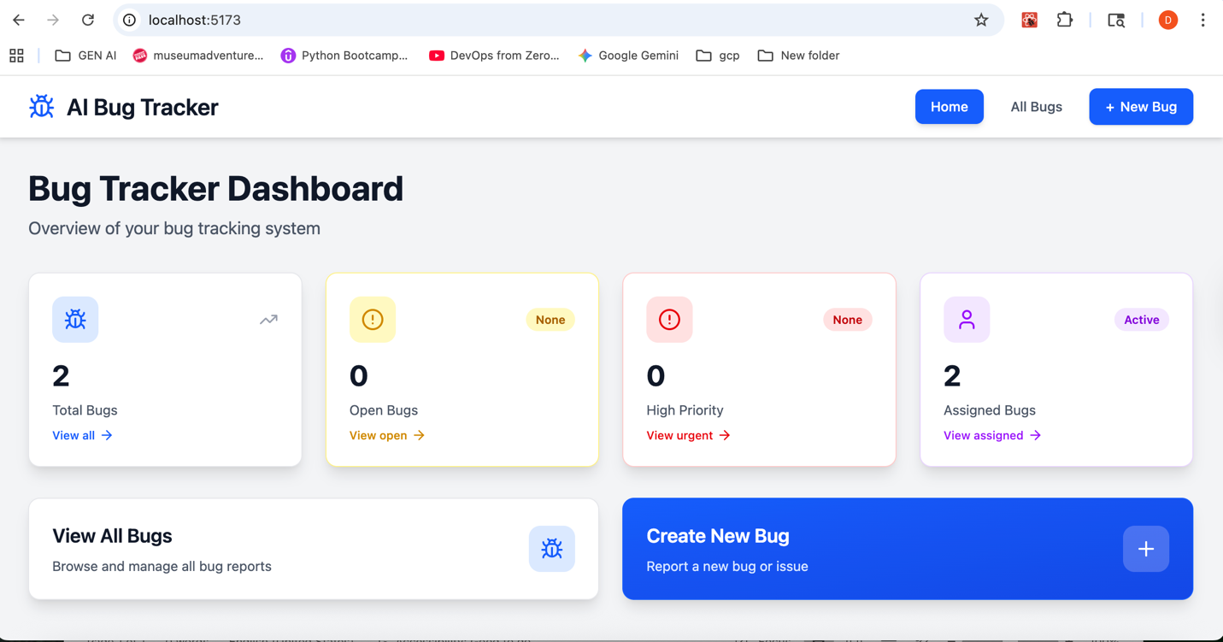
- Bug List page
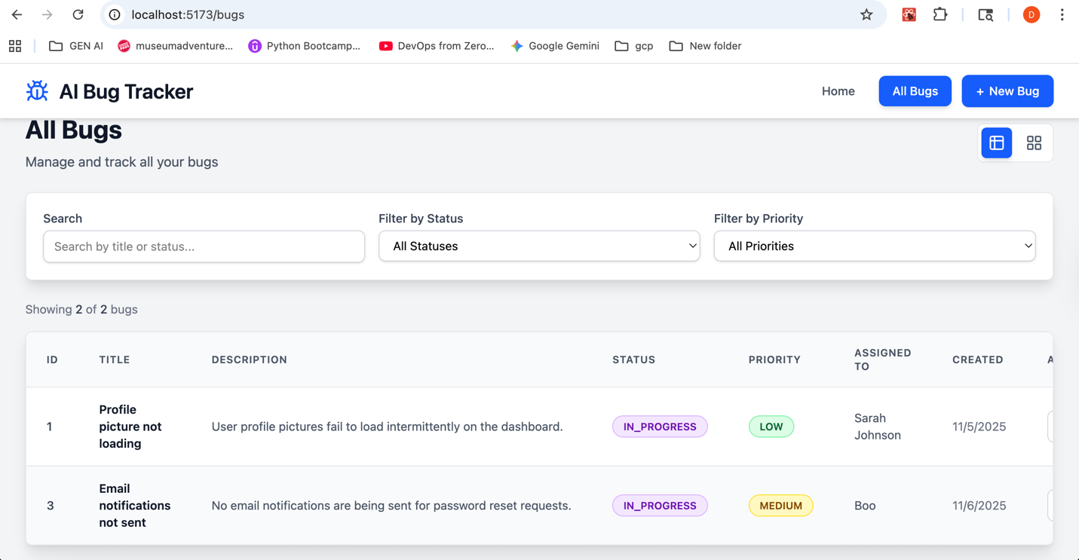
- Create Bug Page
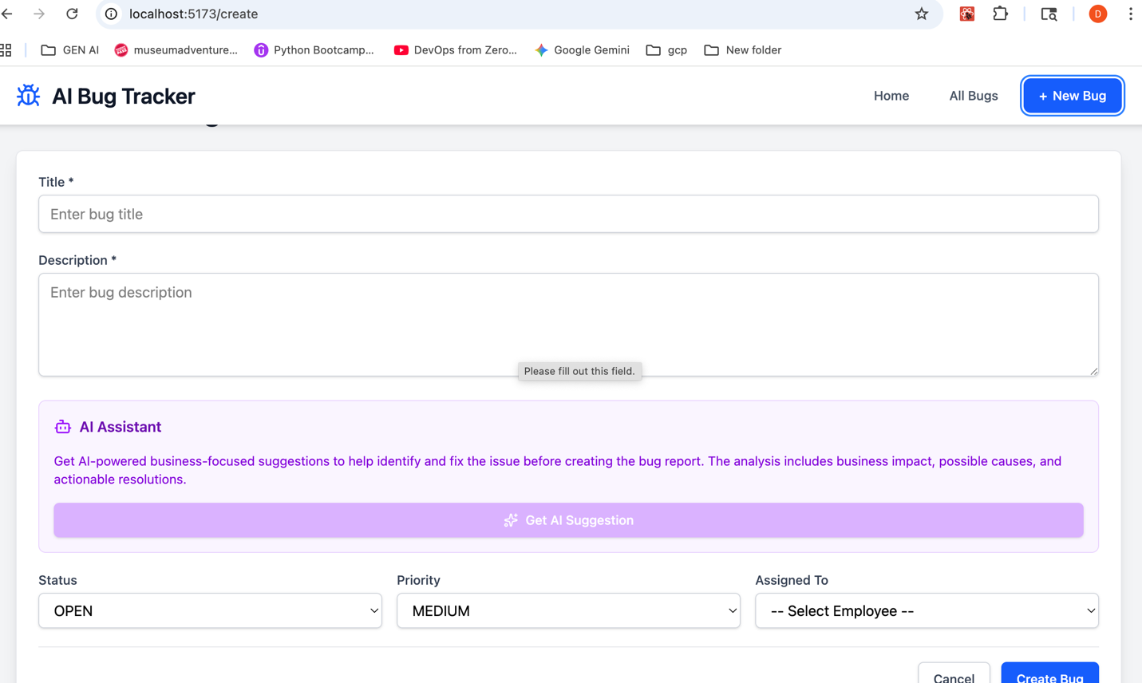

- AI Assistant analysis type: Business before user can check and can do by himself submits the bug he can whether to place or not

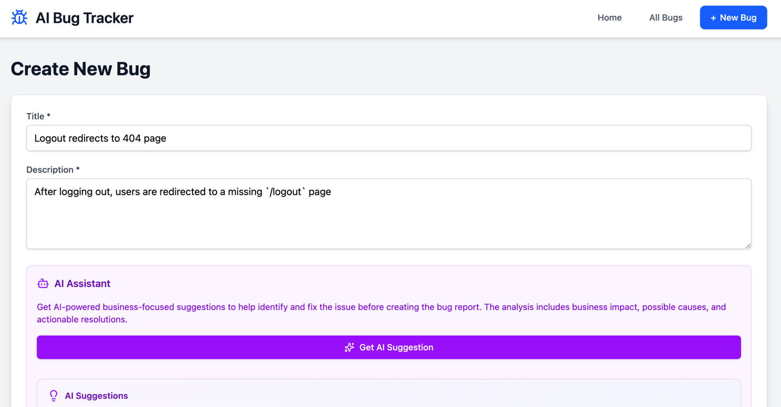

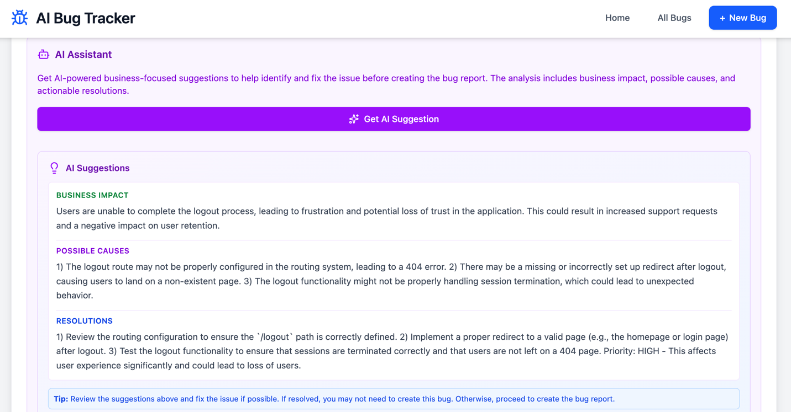
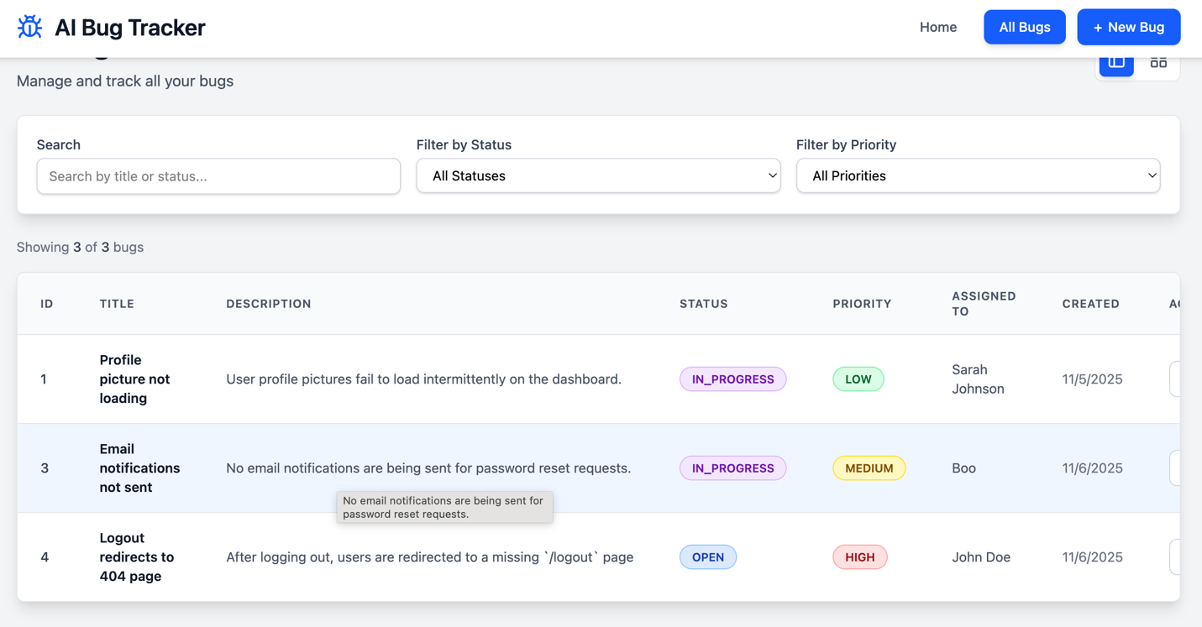
- Edit Bug Page

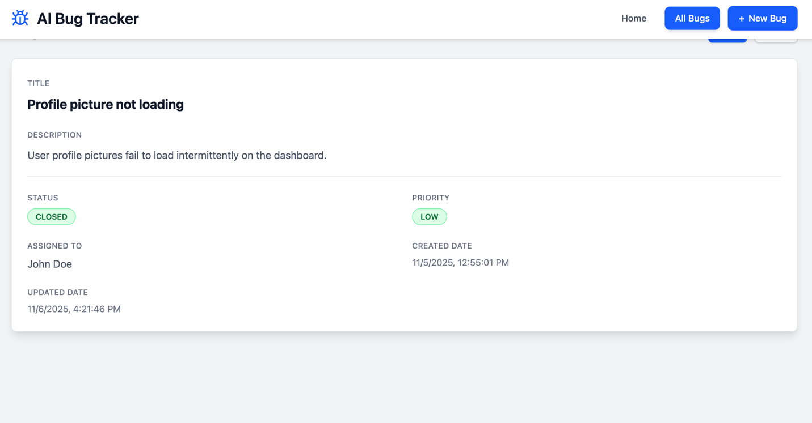
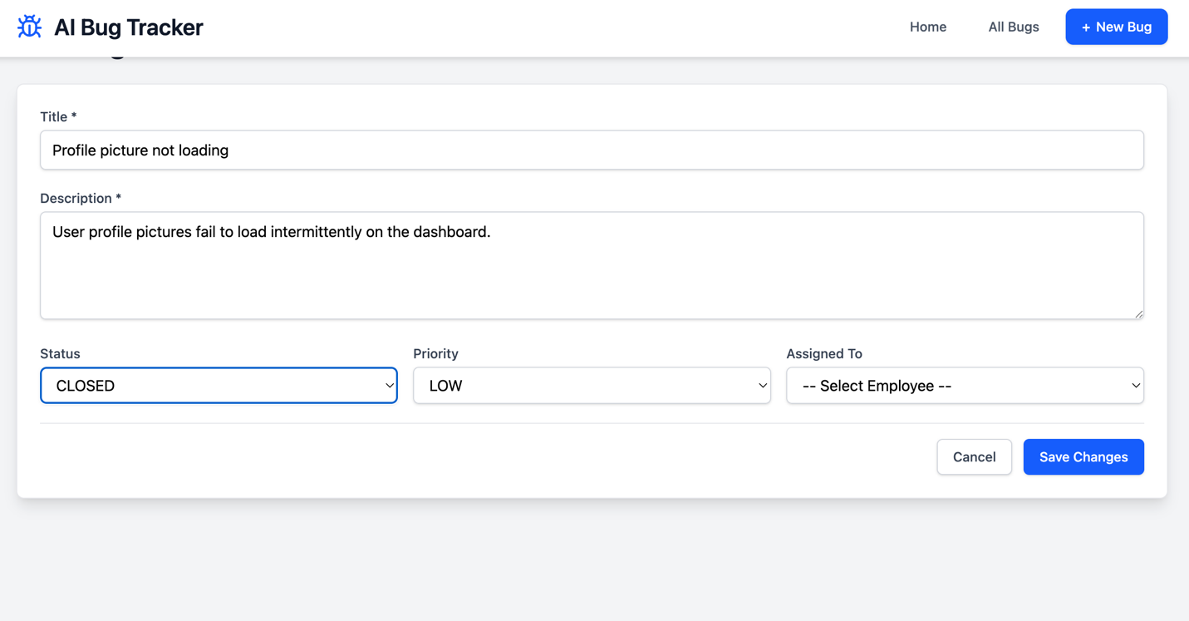

- View Bug page (Here I am using ai assistant for help)
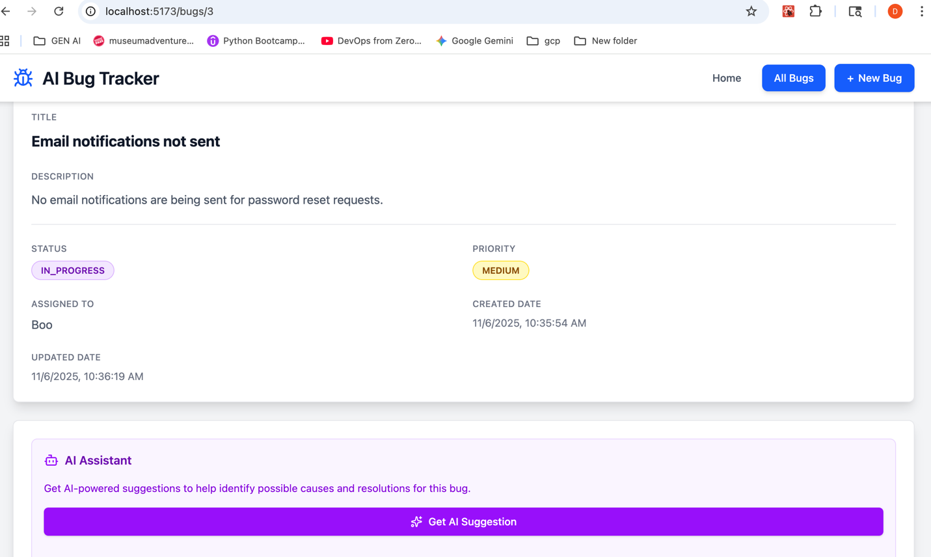

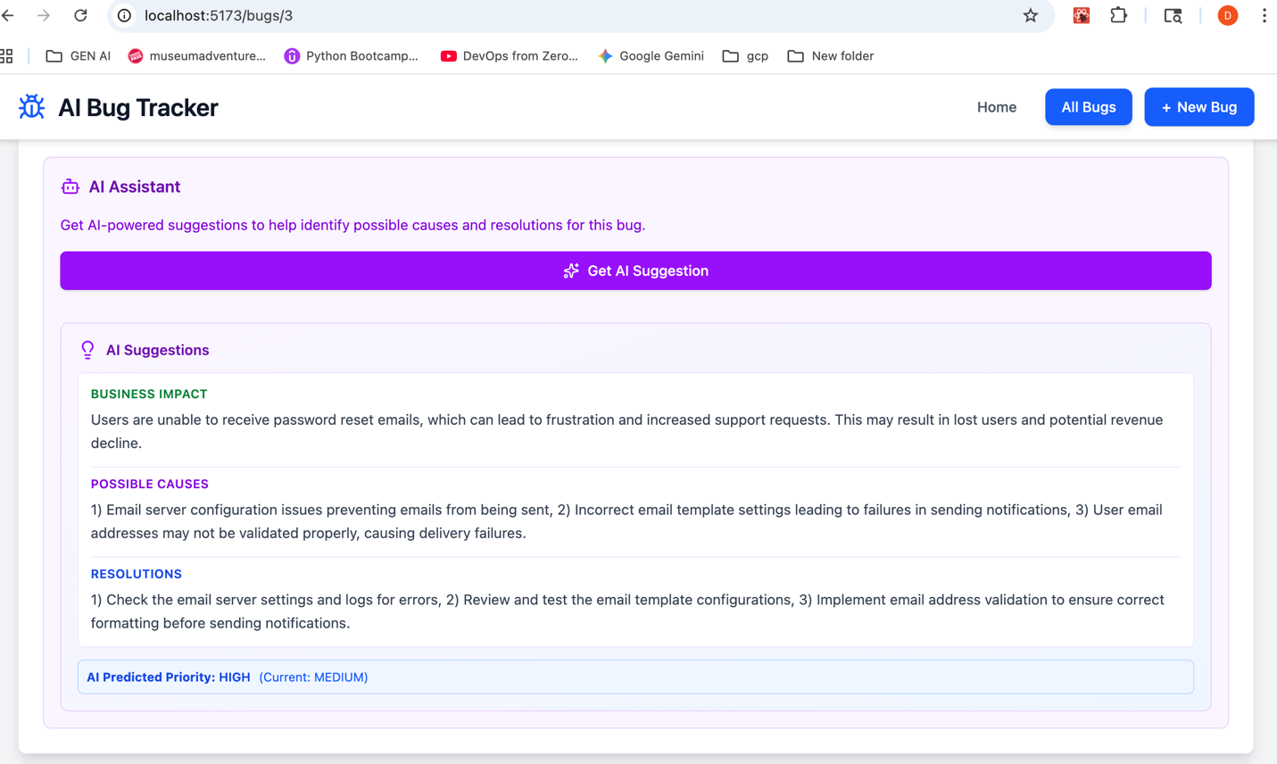

- Delete Bug page

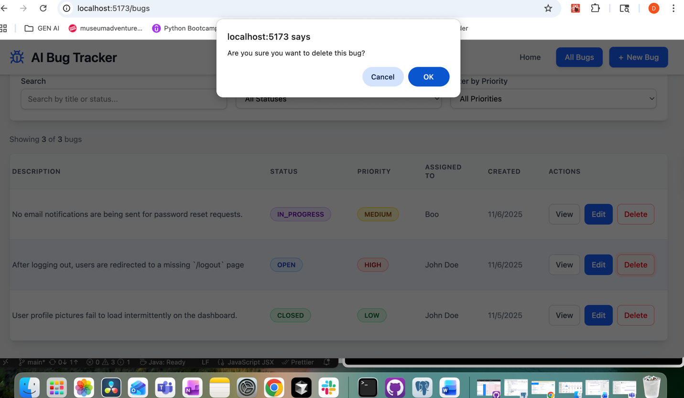

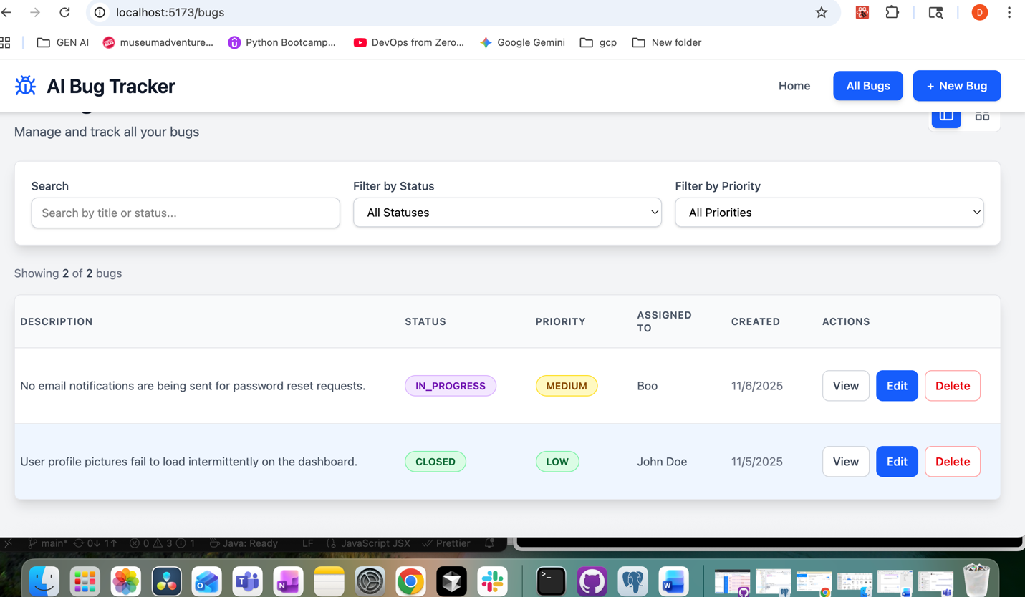
Overview:
AI (Fast API + OpenAI):
- The AI microservice analyzes each bug's title and description to suggest a possible technical resolution.
- It predicts a priority level — LOW, MEDIUM, HIGH, or CRITICAL — based on issue severity.
- It can differentiate between business and developer contexts for better recommendations.
- The AI runs as a separate Fast API service and communicates with the frontend via an API call.
- All AI responses are structured JSON for easy integration into the React interface.

Frontend (React + Vite):
- The React frontend allows users to create, update, and view bugs with a clean, styled interface.
- It features a dashboard with summary statistics and bug listing with table/card view modes.
- Users can search and filter bugs, trigger AI suggestions directly from the bug view page, and assign tasks to employees.
- It communicates with both the Spring Boot backend (for CRUD) and the Fast API AI (for insights).
- All API calls use Axios, and Tailwind + external CSS ensure a responsive design.
- Built with Vite for fast development and optimized builds.

Backend (Spring Boot + PostgreSQL):
- The backend is a RESTful API server that manages all CRUD operations for bugs and employees.
- It stores and retrieves bug data from PostgreSQL using Spring Data JPA for database operations.
- It exposes REST APIs with Swagger documentation for easy testing and integration.
- It also handles automatic bug assignment to available employees and ensures data consistency.

